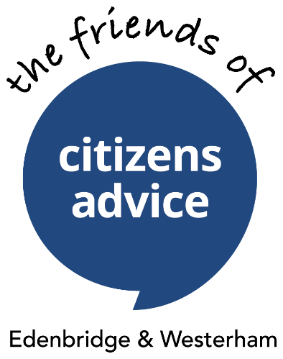
Newsletter
March 2022

Dear Friends supporter
This newsletter comes to you as society is starting to get back on its feet after the Covid-19 pandemic and we are pleased to announce a special event the Friends have organised that will be taking place in May to raise the awareness of local makers of craft, food, produce, art, textiles, handmade clothing, ceramics, jewellery, upcycling, plants and music and all things handmade, homemade and handcrafted in the Edenbridge area.

Saturday 21st May 2022
The Eden Centre
10am-3pm
We have joined forces with the Eden Valley Chamber of Commerce and the Eden Centre to celebrate the creative talents of the people of Edenbridge. All proceeds from the sale of stalls and donations on the day will go to The Friends of Edenbridge and Westerham Citizens Advice to support the running of the advice service.
Two ways you can help
If you know of anyone who is a Maker, please send them this email link to request an order form to book a stall at a cost of £30 for the day. Fewca.makersmarket@gmail.com
We will need all the help we can get on the day and are looking for volunteers to work as stewards for the overflow car park and for each of the rooms with stalls and to guide visitors from room to room and man the Friends stall in reception to meet and greet all visitors.
If you’d like to help, please email Jill at friends.ewcitizensadvice@gmail.com
Your help and support will be really appreciated.

Grant award for debt advice training
We are also delighted to announce that The Friends have been awarded a £2000 grant by Kent County Councillors, Margot McArthur for Edenbridge and Nick Chard for Westerham from their Covid-19 Local Recovery fund to provide debt advice training for volunteer advisers.

As a result of the COVID 19 pandemic, many people have lost significant income - whether as a result of being furloughed, losing their jobs or their businesses being hit by lockdowns and restrictions. Those people claiming Universal Credit have recently had their income reduced by £20 per week.

Many people are now facing a cost of living crisis - with prices generally rising, and the cost of energy increasing significantly as well as taxation rising from April. A significant number of people have incurred debts during the period of the pandemic, others have become unable to service their existing credit liabilities as a result of their drop in income.Many creditors paused debt collection during lockdown but are now contacting clients and instructing bailiffs once again.

The demand for debt advice is therefore increasing sharply.

Volunteer advisers will be mentored through the required MAPS accredited training programme, provided with close supervision, support and guidance, to enable them to provide face to face advice and assistance to vulnerable local debt clients who live in the Edenbridge and Westerham area. At the end of the training programme volunteer advisers will be able to deliver high quality debt advice with minimal supervision.

The funding received by The Friends is therefore allowing the Advice Service to expand its service and build an in house team of debt advisers which will prevent clients being referred to other agencies and allow the Edenbridge and Westerham Citizens Advice to provide an all-round one stop service for local residents at a critical time.

____________________________________________________________________________

A date for the diary
Our first Annual General meeting from before the pandemic will be held on the 17th June 2022 at 11.30am at the Eden Centre and everyone will be welcome.
We are currently looking for a Treasurer and a Secretary to join our committee, so if you are interested, please get in touch with us at friends.ewcitizensadvice@gmail.com so we can nominate you to be elected at the AGM.
______________________________________________________________________
Thank you
We are really grateful for the continued support we receive from our supporters as members or ‘100 Club’ subscribers, or both or as donors. Without you The Friends would not be able to provide the support it does to the Advice Service.
If you have any friends who might be interested in joining The Friends as a member or taking shares in the ‘100 Club’ or making a one off donation, they can visit our website at www.fewca.org
With best wishes to everyone.
Peter and the committee
____________________________________________________________________________

